Annals of Business Administrative Science 14 (2015) **–**
Available at www.gbrc.jp
Online ISSN 1347-4456 Print ISSN 1347-4464
©2015 Global Business Research Center

Title: Subtitle (Flush Left, Headline Style Capitalization)
First Authora) and Second Authorb)

Abstract: A well-prepared abstract can be the most important single paragraph in an article. Most people have their first contact with an article by seeing just the abstract, usually in comparison with several other abstracts, as they are doing a literature search. Readers frequently decide on the basis of the abstract whether to read the entire article. The abstract needs to be dense with information. By embedding key words in your abstract, you enhance the user’s ability to find it (American Psychological Association, 2010, pp. 25–27).

Keywords: provide 4 to 5 keywords divided by a comma

Introduction (Section Heading in Headline Style)
Lorem ipsum dolor sit amet, consectetuer adipiscing elit. Aenean commodo ligula eget dolor. Aenean massa. Cum sociis natoque penatibus et magnis dis parturient montes, nascetur ridiculus mus. Donec quam felis, ultricies nec, pellentesque eu, pretium quis, sem. Nulla consequat massa quis enim. Donec pede justo, fringilla vel, aliquet nec, vulputate eget, arcu. In enim justo, rhoncus ut, imperdiet a, venenatis vitae, justo. Nullam dictum felis eu pede mollis pretium. Integer tincidunt. Cras dapibus. Vivamus elementum semper nisi. Aenean vulputate eleifend tellus. Aenean leo ligula, porttitor eu, consequat vitae, eleifend ac, enim. Aliquam lorem ante, dapibus in, viverra quis, feugiat a, tellus. Phasellus viverra nulla ut metus varius laoreet. Quisque rutrum. Aenean imperdiet. Etiam ultricies nisi vel augue. Curabitur ullamcorper ultricies nisi. Nam eget dui. Etiam rhoncus. Maecenas tempus, tellus eget condimentum rhoncus, sem quam semper libero, sit amet adipiscing sem neque sed ipsum. Nam quam nunc, blandit vel, luctus pulvinar, hendrerit id, lorem. Maecenas nec odio et ante tincidunt tempus. Donec vitae sapien ut libero venenatis faucibus. Nullam quis ante. Etiam sit amet orci eget eros faucibus tincidunt. Duis leo. Sed fringilla mauris sit amet nibh. Donec sodales sagittis magna. Sed consequat, leo eget bibendum sodales, augue velit cursus nunc,
Method
Lorem ipsum dolor sit amet, consectetuer adipiscing elit. Aenean commodo ligula eget dolor. Aenean massa. Cum sociis natoque penatibus et magnis dis parturient montes, nascetur ridiculus mus. Donec quam felis, ultricies nec, pellentesque eu, pretium quis, sem. Nulla consequat massa quis enim. Donec pede justo, fringilla vel, aliquet nec, vulputate eget, arcu. In enim justo, rhoncus ut, imperdiet a, venenatis vitae, justo. Nullam dictum felis eu pede mollis pretium. Integer tincidunt. Cras dapibus. Vivamus elementum semper nisi. Aenean vulputate eleifend tellus. Aenean leo ligula, porttitor eu, consequat vitae, eleifend ac, enim. Aliquam lorem ante, dapibus in, viverra quis, feugiat a, tellus. Phasellus viverra nulla ut metus varius laoreet. Quisque rutrum. Aenean imperdiet. Etiam ultricies nisi vel augue. Curabitur ullamcorper ultricies nisi. Nam eget dui. Etiam rhoncus. Maecenas tempus, tellus eget condimentum rhoncus, sem quam semper libero, sit amet adipiscing sem neque sed ipsum. Nam quam nunc, blandit vel, luctus pulvinar, hendrerit id, lorem. Maecenas nec odio et ante tincidunt tempus. Donec vitae sapien ut libero venenatis faucibus. Nullam quis ante. Etiam sit amet orci eget eros faucibus tincidunt. Duis leo. Sed fringilla mauris sit amet nibh. Donec sodales sagittis magna. Sed consequat, leo eget bibendum sodales, augue velit cursus nunc,
If the quotation comprises 40 or more words, display it in a freestanding block of text and omit the quotation marks. Start such a block quotation on a new line and indent the block about a half inch from the left margin (in the same position as a new paragraph). If there are additional paragraphs within the quotation, indent the first line of each an additional half inch. Double-space the entire quotation. At the end of a block quotation, cite the quoted source and the page or paragraph number in parentheses after the final punctuation mark (American Psychological Association, 2010, p. 171).
Lorem ipsum dolor sit amet, consectetuer adipiscing elit. Aenean commodo ligula eget dolor. Aenean massa. Cum sociis natoque penatibus et magnis dis parturient montes, nascetur ridiculus mus. Donec quam felis, ultricies nec, pellentesque eu, pretium quis, sem. Nulla consequat massa quis enim. Donec pede justo, fringilla vel, aliquet nec, vulputate eget, arcu. In enim justo, rhoncus ut, imperdiet a, venenatis vitae, justo. Nullam dictum felis eu pede mollis pretium. Integer tincidunt. Cras dapibus. Vivamus elementum semper nisi. Aenean vulputate eleifend tellus. Aenean leo ligula, porttitor eu, consequat vitae, eleifend ac, enim. Aliquam lorem ante, dapibus in, viverra quis, feugiat a, tellus. Phasellus viverra nulla ut metus varius laoreet. Quisque rutrum. Aenean imperdiet. Etiam ultricies nisi vel augue. Curabitur ullamcorper ultricies nisi. Nam eget dui. Etiam rhoncus. Maecenas tempus, tellus eget condimentum rhoncus, sem quam semper libero, sit amet adipiscing sem neque sed ipsum. Nam quam nunc, blandit vel, luctus pulvinar, hendrerit id, lorem. Maecenas nec odio et ante tincidunt tempus. Donec vitae sapien ut libero venenatis faucibus. Nullam quis ante. Etiam sit amet orci eget eros faucibus tincidunt. Duis leo. Sed fringilla mauris sit amet nibh. Donec sodales sagittis magna. Sed consequat, leo eget bibendum sodales, augue velit cursus nunc,
Discussion
Lorem ipsum dolor sit amet, consectetuer adipiscing elit. Aenean commodo ligula eget dolor. Aenean massa. Cum sociis natoque penatibus et magnis dis parturient montes, nascetur ridiculus mus. Donec quam felis, ultricies nec, pellentesque eu, pretium quis, sem. Nulla consequat massa quis enim. Donec pede justo, fringilla vel, aliquet nec, vulputate eget, arcu. In enim justo, rhoncus ut, imperdiet a, venenatis vitae, justo. Nullam dictum felis eu pede mollis pretium. Integer tincidunt. Cras dapibus. Vivamus elementum semper nisi. Aenean vulputate eleifend tellus. Aenean leo ligula, porttitor eu, consequat vitae, eleifend ac, enim. Aliquam lorem ante, dapibus in, viverra quis, feugiat a, tellus. Phasellus viverra nulla ut metus varius laoreet. Quisque rutrum. Aenean imperdiet. Etiam ultricies nisi vel augue. Curabitur ullamcorper ultricies nisi. Nam eget dui. Etiam rhoncus. Maecenas tempus, tellus eget condimentum rhoncus, sem quam semper libero, sit amet adipiscing sem neque sed ipsum. Nam quam nunc, blandit vel, luctus pulvinar, hendrerit id, lorem. Maecenas nec odio et ante tincidunt tempus. Donec vitae sapien ut libero venenatis faucibus. Nullam quis ante. Etiam sit amet orci eget eros faucibus tincidunt. Duis leo. Sed fringilla mauris sit amet nibh. Donec sodales sagittis magna. Sed consequat, leo eget bibendum sodales, augue velit cursus nunc,
Conclusion
Lorem ipsum dolor sit amet, consectetuer adipiscing elit. Aenean commodo ligula eget dolor. Aenean massa. Cum sociis natoque penatibus et magnis dis parturient montes, nascetur ridiculus mus. Donec quam felis, ultricies nec, pellentesque eu, pretium quis, sem. Nulla consequat massa quis enim. Donec pede justo, fringilla vel, aliquet nec, vulputate eget, arcu. In enim justo, rhoncus ut, imperdiet a, venenatis vitae, justo. Nullam dictum felis eu pede mollis pretium. Integer tincidunt. Cras dapibus. Vivamus elementum semper nisi. Aenean vulputate eleifend tellus. Aenean leo ligula, porttitor eu, consequat vitae, eleifend ac, enim. Aliquam lorem ante, dapibus in, viverra quis, feugiat a, tellus. Phasellus viverra nulla ut metus varius laoreet. Quisque rutrum. Aenean imperdiet. Etiam ultricies nisi vel augue. Curabitur ullamcorper ultricies nisi. Nam eget dui. Etiam rhoncus. Maecenas tempus, tellus eget condimentum rhoncus, sem quam semper libero, sit amet adipiscing sem neque sed ipsum. Nam quam nunc, blandit vel, luctus pulvinar, hendrerit id, lorem. Maecenas nec odio et ante tincidunt tempus. Donec vitae sapien ut libero venenatis faucibus. Nullam quis ante. Etiam sit amet orci eget eros faucibus tincidunt. Duis leo. Sed fringilla mauris sit amet nibh. Donec sodales sagittis magna. Sed consequat, leo eget bibendum sodales, augue velit cursus nunc,
Acknowledgements
Identify grants or other financial support (and the source, if appropriate) for your study (American Psychological Association, 2010, p. 25).
References
Adams, R. J. (1973). Building a foundation for evaluation of instruction in higher education and continuing education (Doctoral dissertation). Retrieved from http://www.ohiolink.edu/etd/
American Psychological Association (2010). Publication manual of the American Psychological Association (6th ed.). Washington, DC: American Psychological Association.
Bruckman, A. (1997). MOOSE crossing: Construction, community, and learning in a networked virtual world for kids (Doctoral dissertation, Massachusetts Institute of Technology). Retrieved from http://www-static.cc.gatech.edu/~asb/thesis/
Christensen, C. M., Suarez, F. F., & Utterback, J. M. (1996). Strategies for survival in fast-changing industries. (Working Paper, July 16, 97-009). Cambridge, MA: Harvard Business School.
Freud, S. (1953). The method of interpreting dreams: An analysis of a specimen dream. In J. Strachey (Ed. & Trans.), The standard edition of the complete psychological works of Sigmund Freud (Vol. 4, pp. 96–121). Retrieved from http://books.google.com/books (Original work published 1900)
Gibbs, J. T., & Huang, L. N. (Eds.). (1991). Children of color: Psychological interventions with minority youth. San Francisco: Jossey-Bass.
Ising, M. (2000). Intensitätsabhängigkeit evozierter Potenzial im EEG: Sind impulsive Personen Augmenter oder Reducer? [Intensity dependence in event-related EEG potentials: Are impulsive individuals augmenters or reducers?]. Zeitschrift für Differentielle und Diagnostische Psychologie, 21, 208–217.
Klimoski, R., & Palmer, S. (1993). The ADA and the hiring process in organizations. Consulting Psychology Journal: Practice and Research, 45(2), 10–36.
Laplace, P. S. (1951). A philosophical essay on probabilities (F. W. Truscott & F. L. Emory, Trans.). New York: Dover. (Original work published 1814)
Liu, S. (2005, May). Defending against business crises with the help of intelligent agent based early warning solutions. Paper presented at the Seventh International Conference on Enterprise Information Systems, Miami, FL. Abstract retrieved from http://www.iceis.org/iceis2005/abstracts_2005htm
Massaro, D. (1992). Broadening the domain of the fuzzy logical model of perception. In H. L. Pick Jr., P. van den Broek, & D. C. Knill (Eds.), Cognition: Conceptual and methodological issues (pp. 51–84). Washington, DC: American Psychological Association.
Mellers, B. A. (2000). Choice and the relative pleasure of consequences. Psychological Bulletin, 126, 910–924.
Merriam-Webster’s collegiate dictionary (10th ed.). (1993). Springfield, MA: Merriam-Webster.
Mitchell, T. R., & Larson, J. R., Jr. (1987). People in organizations: An introduction to organizational behavior (3rd ed.). New York: McGraw-Hill.
Muellbauer, J. (2007, September). Housing, credit, and consumer expenditure. In S. C. Ludvigson (Chair), Housing and consumer behavior. Symposium conducted at the meeting of the Federal Reserve Bank of Kansas City, Jackson Hole, WY.
Rosenthal, R. (1987). Meta-analytic procedures for social research (Rev. ed.). Newbury Park, CA: Sage.
Saywitz, K. J., Mannarino, A. P., Berliner, L., & Cohen, J. A. (2000). Treatment for sexually abused children and adolescents. American Psychologist, 55, 1040–1049.
Shotton, M. A. (1989). Computer addiction? A study of computer dependency. London, England: Taylor & Francis.
Stutte, H. (1972). Transcultural child psychiatry. Acta Paedopsychiatrica, 38(9), 229–231.
Takahashi, N. (1993). Nurumayuteki keiei no kenkyu [A study of lukewarm management]. Tokyo: Toyokeizai (in Japanese).
Wolchik, S. A., West, S. G., Sander, I. N., Tein, J., Coatsworth, D., Lengua, L., et al. (2000). An experimental evaluation of theory-based mother-child programs for children of divorce. Journal of Consulting and Clinical Psychology, 68, 843–856.

Received day month year; accepted day month year
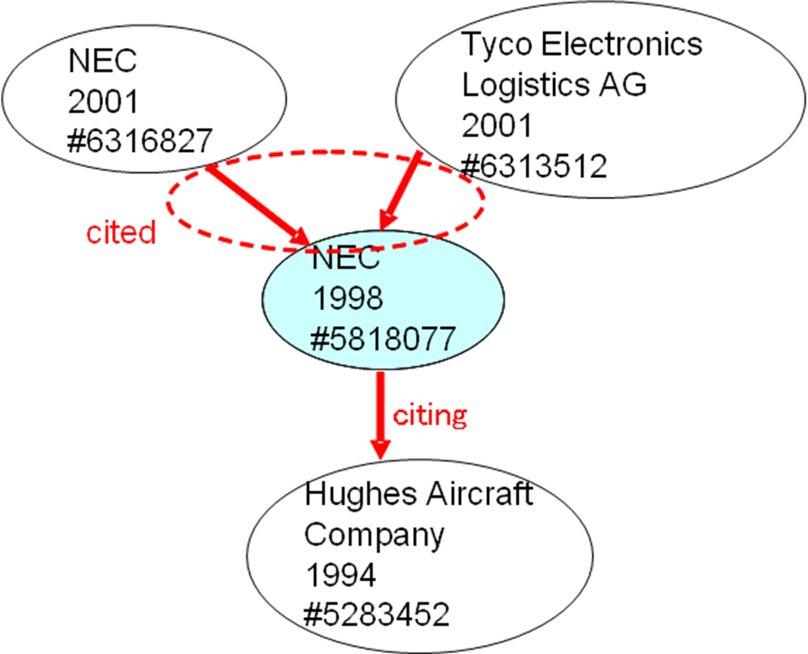
Figure 1. Sample figure
Note: Sample note
Source: Sample source.
Table 1. Sample table
 |  | Number of patents | Number of citations | Number of self-citations | Self-citation ratio
American firms | TI | 1,418 | 10,546 | 2,196 | 0.21
American firms | IBM | 1,331 | 13,691 | 2,534 | 0.19
American firms | Motorola | 1,303 | 9,084 | 1,333 | 0.15
American firms | Micron Technology | 1,168 | 12,709 | 1,888 | 0.15
American firms | AMD | 802 | 6,886 | 730 | 0.11
American firms | Intel | 320 | 2,517 | 177 | 0.07
Note: Sample note.
Source: Sample source.

a ) First author affiliation, first author affiliation address, email address
b ) Second author affiliation, second author affiliation address, email address A part of this paper was originally published as citation (20ZZ) in Japanese.
Footnotes are used to provide additional content or to acknowledge copyright permission status (American Psychological Association, 2010, p. 37).

